Создание таблиц

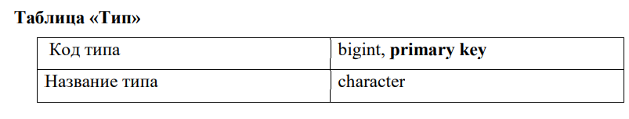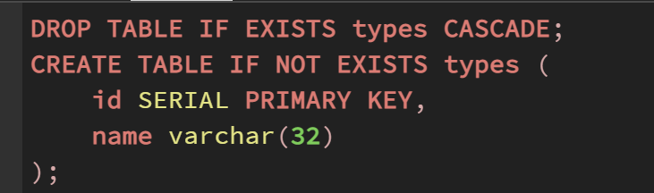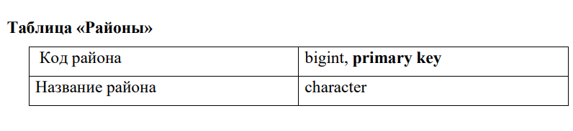

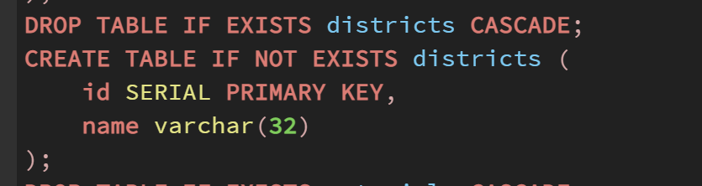

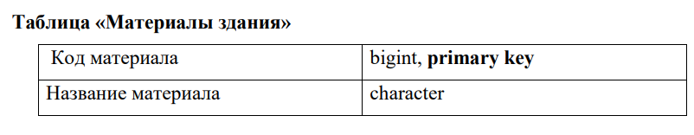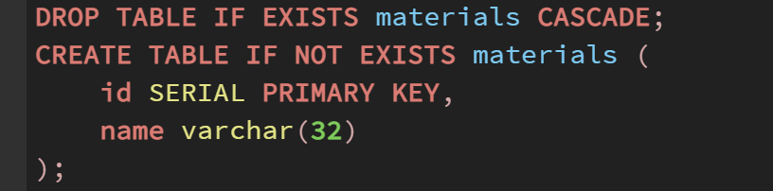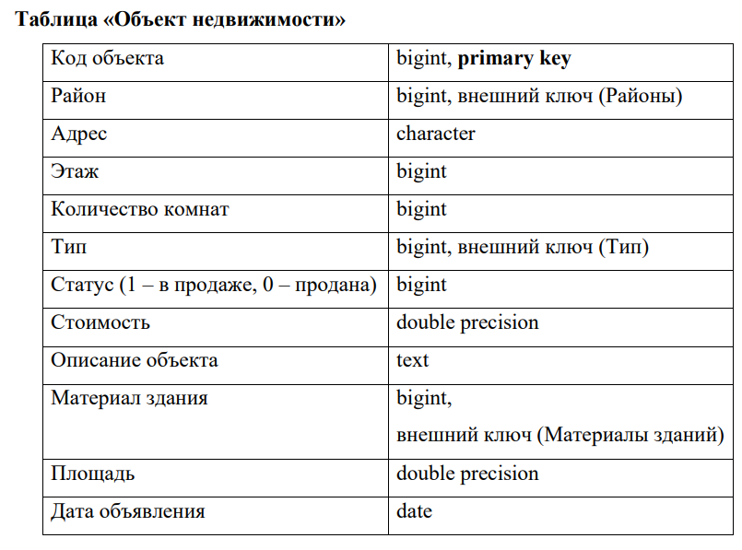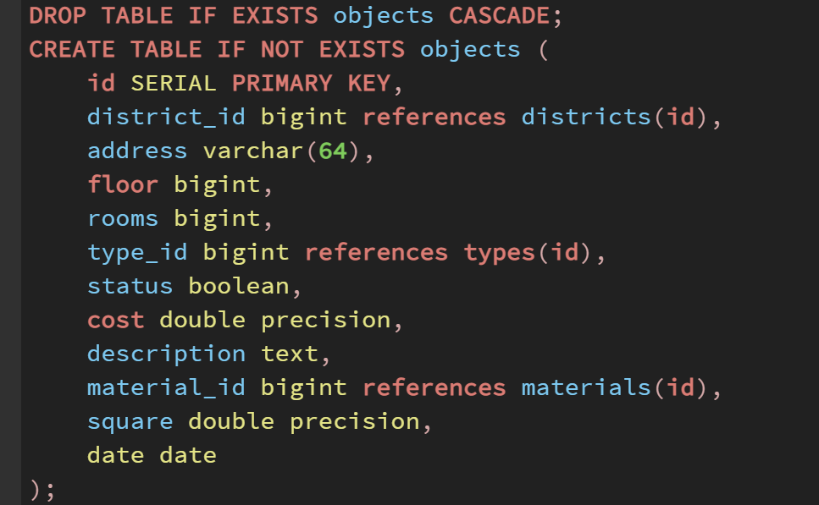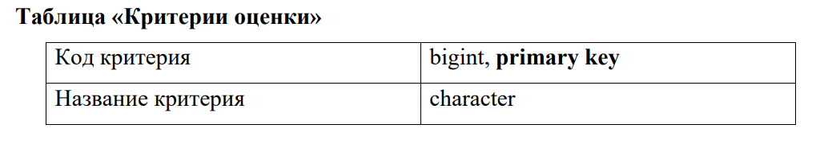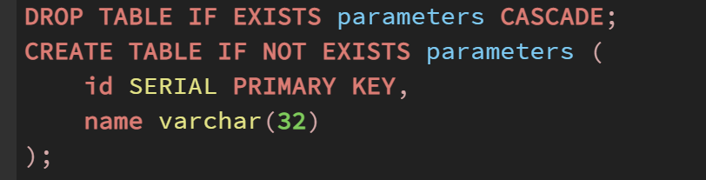­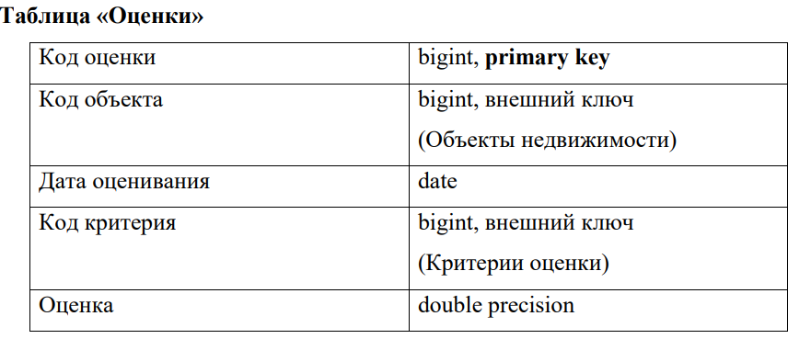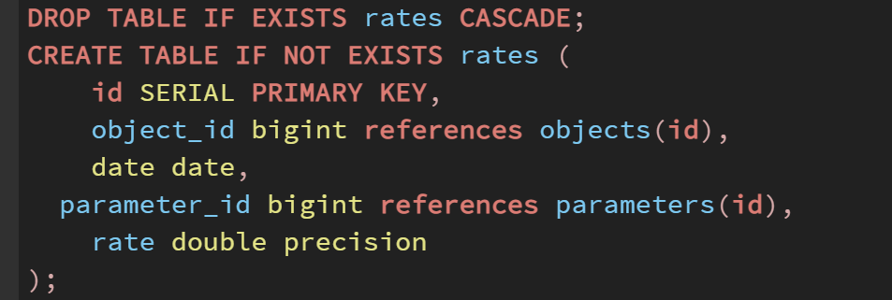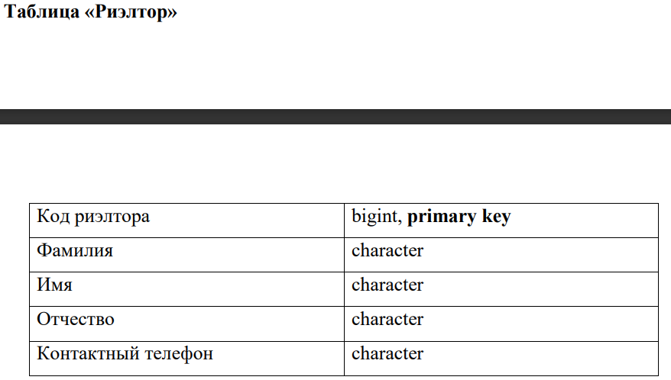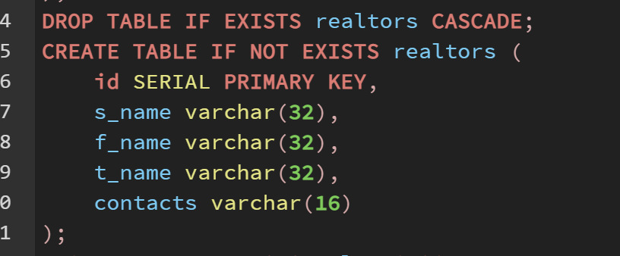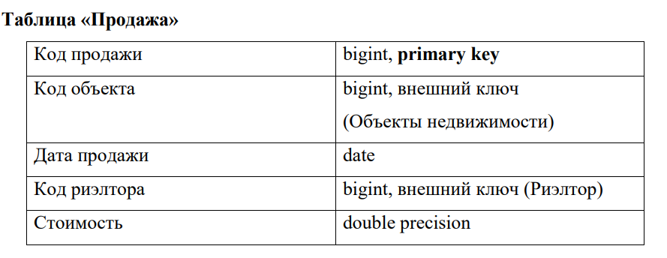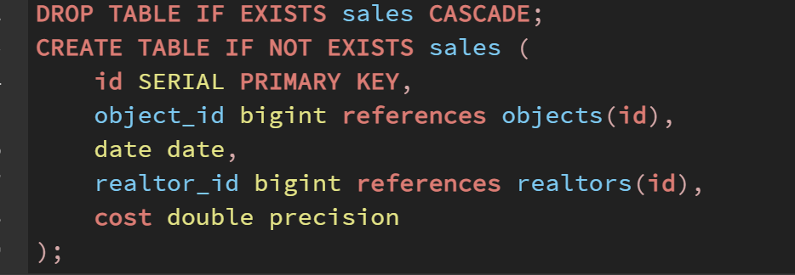

**Запросы**

Вывести все панельные объекты недвижимости, расположенные на указанном этаже и статусом «в продаже» 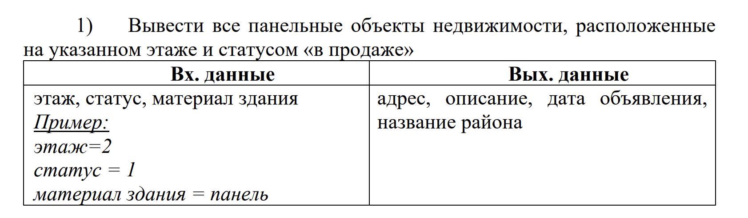

select objects.address, objects.description, objects.date, districts.name, materials.name, floor

from objects, materials, districts

where objects.status = true and

objects.material_id=materials.id and

floor = 2 and

materials.name='Панель'

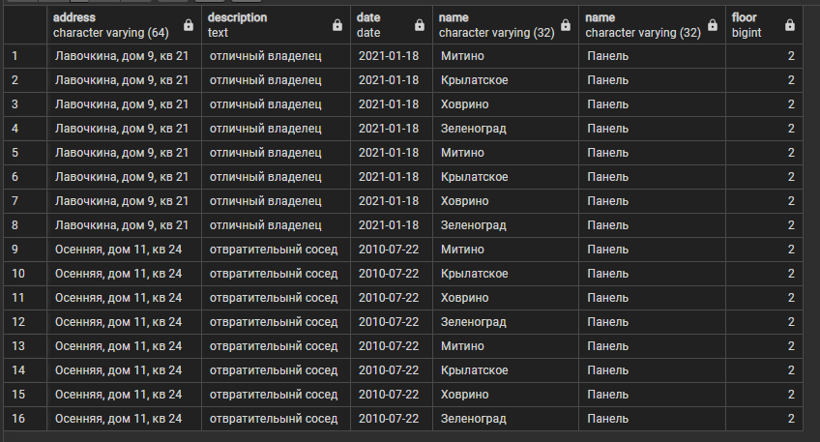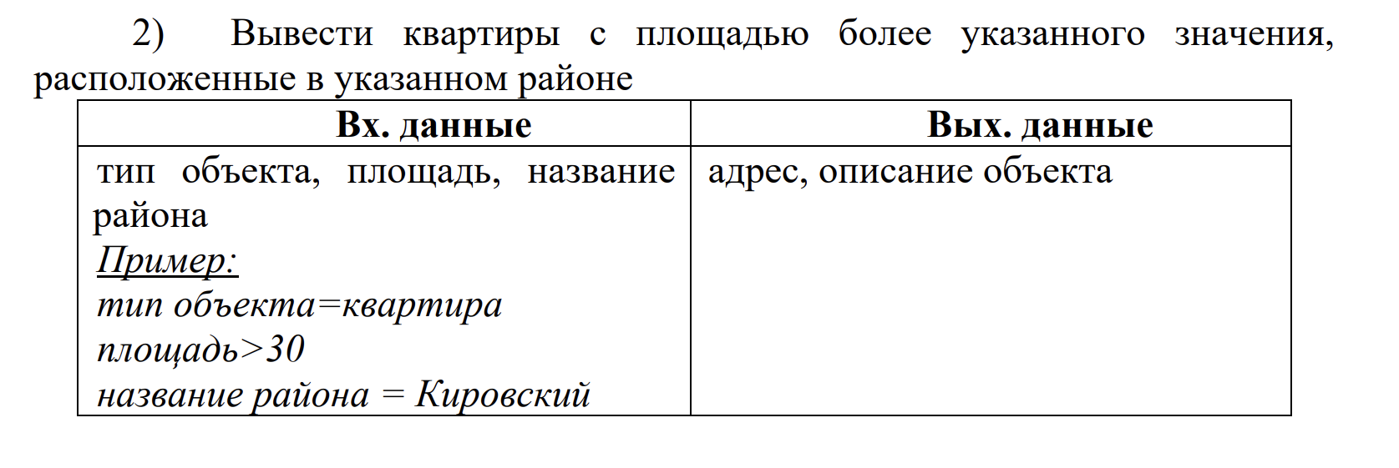

select objects.address, objects.description, objects.square, districts.name

from objects, districts

where objects.square > 30 and

objects.district_id = districts.id and

districts.name = 'Митино' 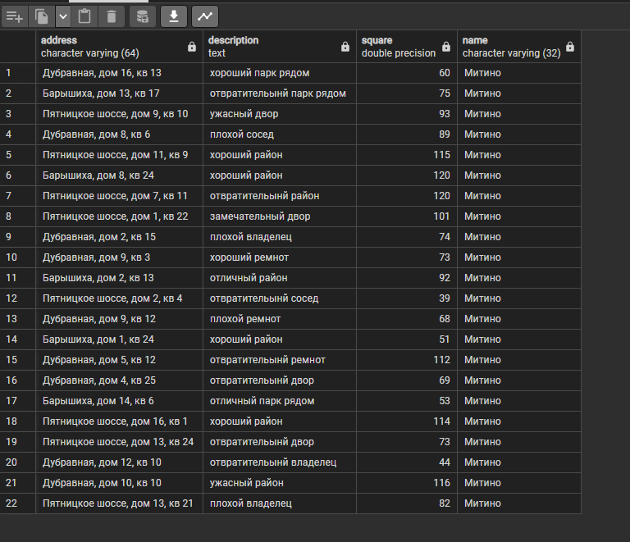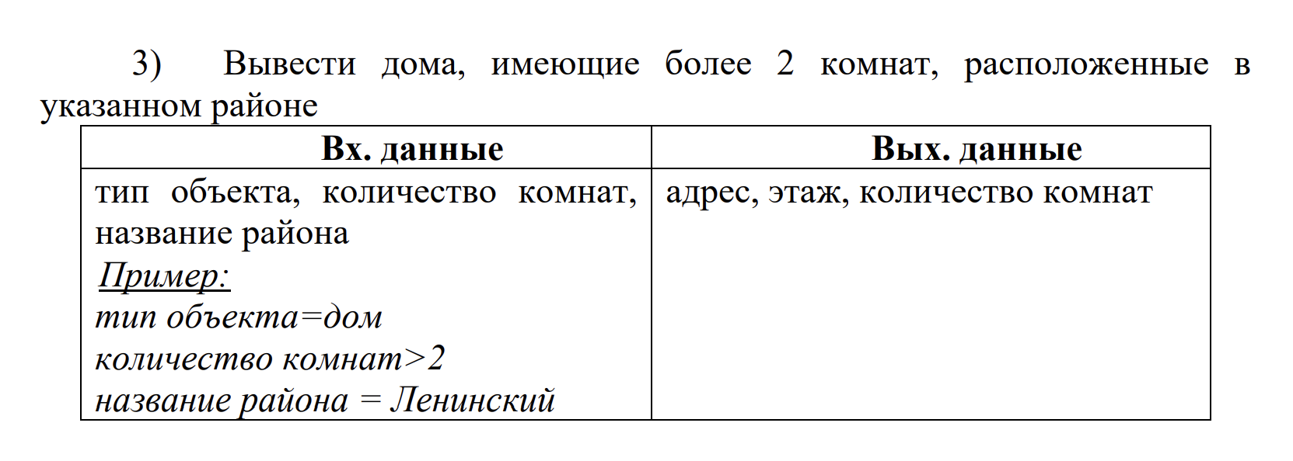

SELECT

objects.address, objects.floor, objects.rooms

FROM

objects, districts, types

WHERE

types.name = 'Дом'

AND

objects.type_id = types.id

AND

objects.rooms > 2

AND

objects.district_id = districts.id

AND

districts.name = 'Митино';

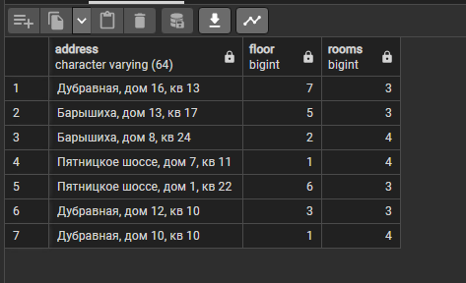

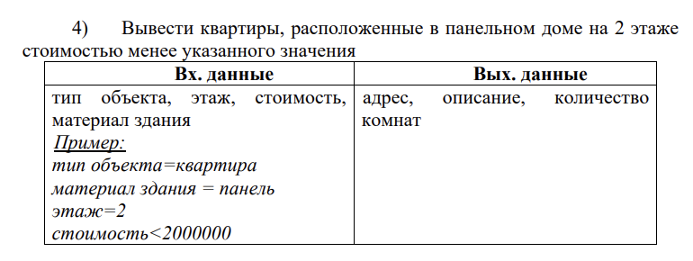 SELECT

objects.address, objects.description, objects.rooms, objects.cost

FROM

objects, materials, types

WHERE

-- types.name = 'Квартира' AND

objects.type_id = types.id

AND

materials.name = 'Панель'

AND objects.material_id = materials.id

AND

objects.floor = 2

AND

objects.cost < 20000000;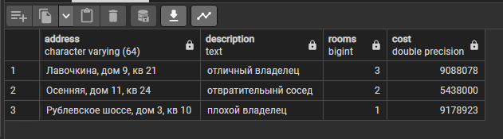 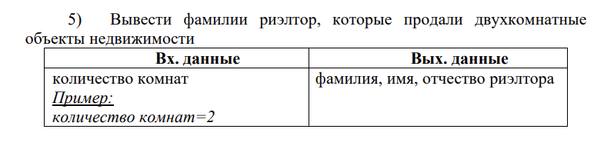

SELECT DISTINCT

realtors.s_name, realtors.f_name, realtors.t_name

FROM

realtors, objects, sales

WHERE

objects.id = sales.object_id

AND

sales.realtor_id = realtors.id

AND

objects.rooms = 2;

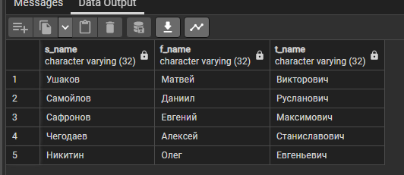

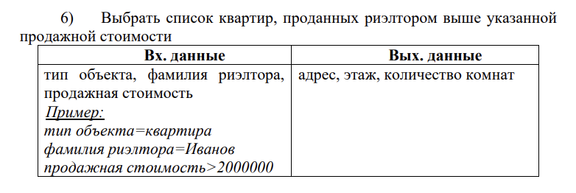 SELECT DISTINCT

objects.address, objects.floor, objects.rooms

FROM

objects, realtors, sales, types

WHERE

types.id = objects.type_id

AND

types.name = 'Квартира'

AND

objects.id = sales.object_id

AND

sales.realtor_id = realtors.id

AND

sales.cost > 2000000

AND

realtors.s_name = 'Чегодаев'; 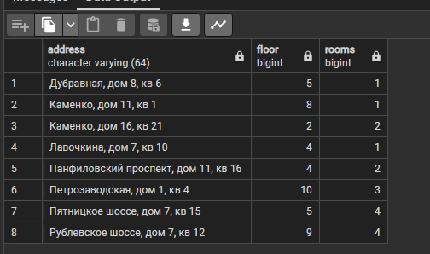

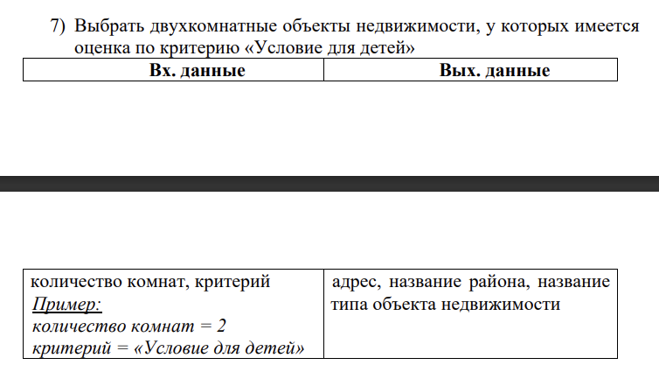

SELECT DISTINCT

objects.address, districts.name, types.name

FROM

objects, districts, types, parameters, rates

WHERE

objects.district_id = districts.id

AND

objects.type_id = types.id

AND

objects.rooms = 2

AND

rates.object_id = objects.id

AND

parameters.id = rates.parameter_id

AND

parameters.name = 'Условия для детей';

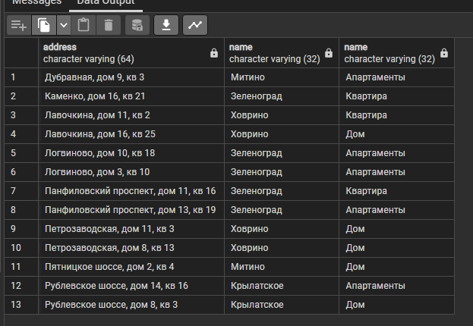 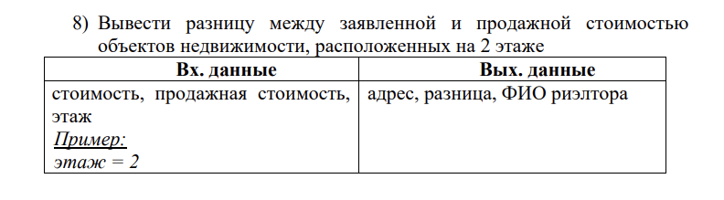

SELECT

objects.address, objects.cost - sales.cost, realtors.f_name, realtors.s_name, realtors.t_name

FROM

objects, sales, realtors

WHERE

objects.floor = 2

AND

sales.object_id = objects.id

AND

sales.realtor_id = realtors.id;

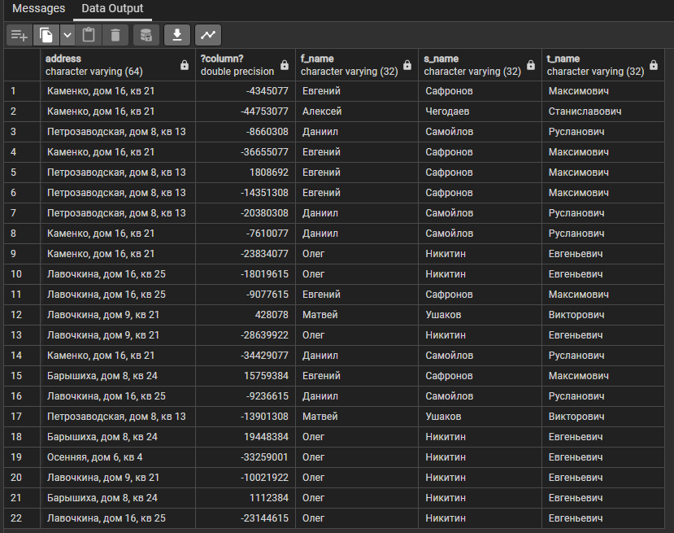

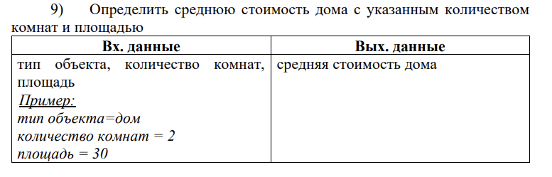 SELECT

AVG(objects.cost)

FROM

objects, types

WHERE

objects.type_id = types.id

AND

types.name = 'Дом'

AND

objects.rooms = 2

AND

objects.square = 10;

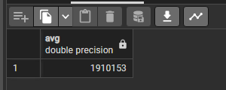 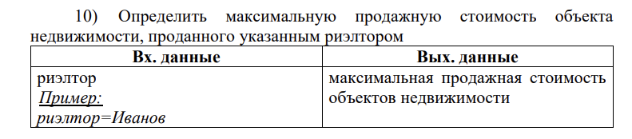

SELECT

MAX(sales.cost)

FROM

sales, realtors

WHERE

realtors.s_name = 'Чегодаев'

AND

sales.realtor_id = realtors.id;

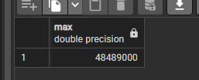

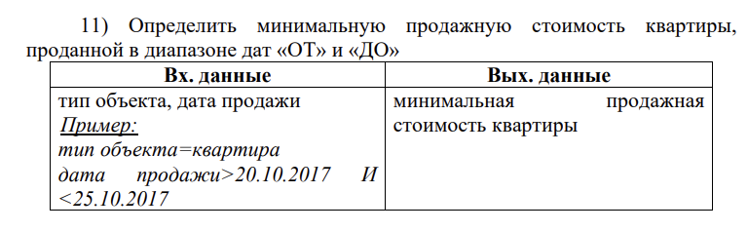

SELECT

MIN(sales.cost)

FROM

sales, objects, types

WHERE

objects.type_id = types.id AND types.name = 'Квартира'

AND sales.object_id = objects.id

AND sales.date > '20.10.2019'

AND sales.date < '25.12.2019'

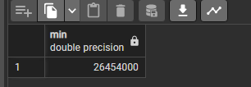

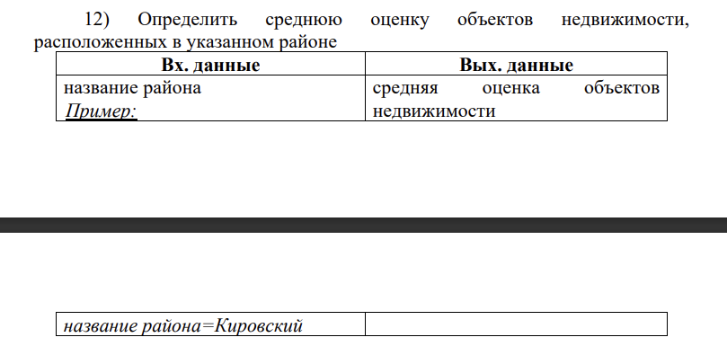

SELECT

AVG(objects.cost)

FROM

objects, districts

WHERE

objects.district_id = districts.id

AND

districts.name = 'Митино';

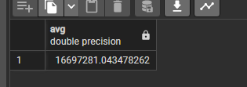

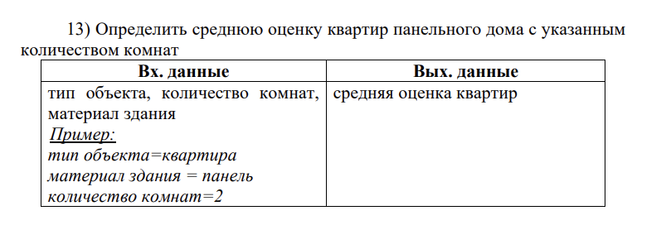

SELECT

AVG(objects.cost)

FROM

objects, types, materials

WHERE

objects.material_id = materials.id AND materials.name = 'Панель'

AND

objects.type_id = types.id AND types.name = 'Квартира'

AND

objects.rooms = 2;

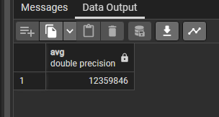

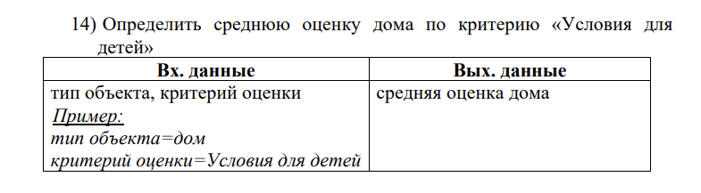

SELECT

AVG(rates.rate)

FROM

objects, types, parameters, rates

WHERE

objects.type_id = types.id AND types.name = 'Дом'

AND

rates.object_id = objects.id

AND

rates.parameter_id = parameters.id AND parameters.name = 'Условия для детей';

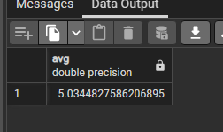

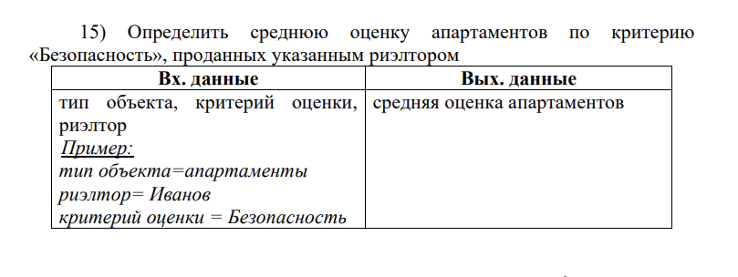 SELECT

AVG(rates.rate)

FROM

objects, types, parameters, rates, realtors, sales

WHERE

objects.type_id = types.id AND types.name = 'Апартаменты'

AND

rates.object_id = objects.id

AND

rates.parameter_id = parameters.id AND parameters.name = 'Безопасность'

AND

objects.id = sales.object_id AND sales.realtor_id = realtors.id

AND

realtors.s_name = 'Сафронов';

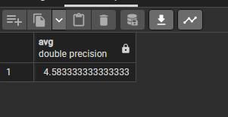

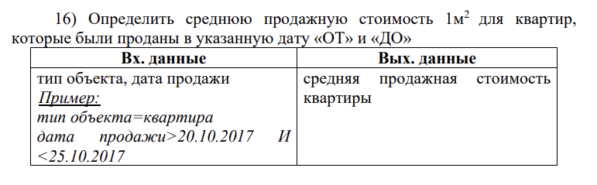 SELECT

AVG(sales.cost / objects.square)

FROM

sales, objects, types

WHERE

objects.type_id = types.id AND types.name = 'Квартира'

AND

sales.object_id = objects.id

AND sales.date > '20.10.2019'

AND sales.date < '25.12.2019'

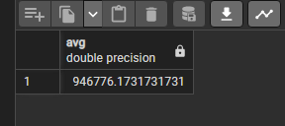

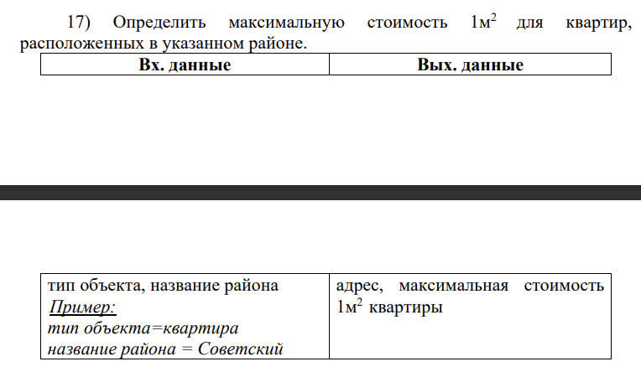

SELECT

MAX(sales.cost / objects.square)

FROM

sales, objects, types, districts

WHERE

objects.type_id = types.id AND types.name = 'Квартира'

AND

objects.district_id = districts.id AND districts.name = 'Митино'; 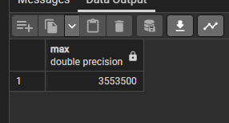

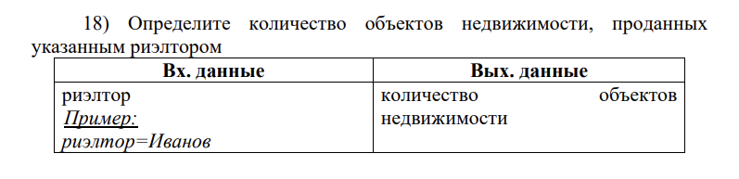

SELECT

COUNT(objects.id)

FROM

objects, realtors, sales

WHERE

sales.object_id = objects.id AND sales.realtor_id = realtors.id

AND

realtors.s_name = 'Самойлов';

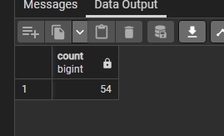

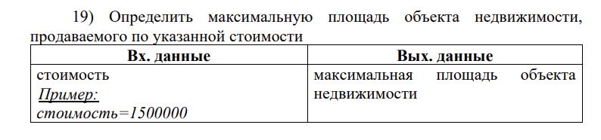

SELECT

MAX(objects.square)

FROM

objects, sales

WHERE

sales.object_id = objects.id

AND

sales.cost > 10000000;

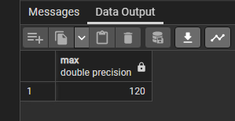

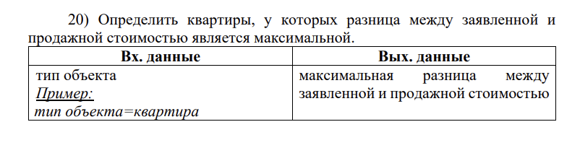

SELECT

MAX(objects.cost - sales.cost)

FROM

objects, sales, types

WHERE

objects.type_id = types.id AND types.name = 'Квартира'

AND

sales.object_id = objects.id;

